ETA Sector Strategies Technical Assistance Initiative:
Case Studies of Sector Strategies in Action

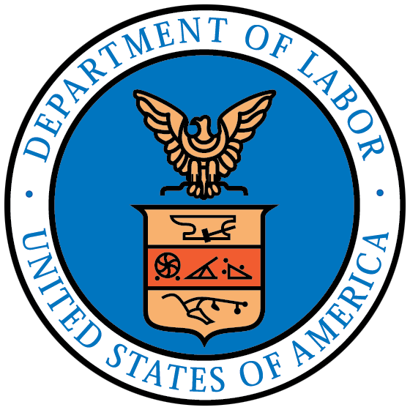

Introduction to the Matrix
The ETA Sector Strategies Technical Assistance Initiative (2014-16), has uncovered a number of best practices and case studies from across the country that showcase sector strategies in action. The following matrix includes many of these cases and was to quickly and easily located the longer written story. The tool is divided by local and state examples and is organized by key topic area. Follow the linked location names to find the document, brief, video, podcast, or interview transcript with information on the practice. The topics are also linked to the corresponding WorkforceGPS webpages with additional information.
The examples included in this matrix are just a sample of the practices currently in use across the country, and are not intended to be a definitive list. The example cases here are those that include the publicly-funded workforce system as a major player. More will continue to be added to this list as the use of sector strategies continues to develop as an invaluable workforce development tool.

Additional resources:
For more information on Sector Strategies, visit WorkforceGPS at: https://businessengagement.workforcegps.org/resources/2016/08/16/15/22/Sector-Strategies-Resources, and don’t miss the WorkforceGPS ION Network’s Using Sector Strategies and Industry Focus Groups to Support Local Businesses inventory page!

Matrix of Promising Practices

Topic | Local/Regional | State
Data-Informed Decision Making – Demand and Supply  Understanding the importance of data in workforce decision making is often the first step to creating a sector-strategy that is both successful and sustainable, meeting the needs of all customers and laying the groundwork for a thriving economy. | Chicago, IL  Audio interview here  Seattle, King County, WA  Seattle, WA  San Diego, CA  Southwest Missouri  Gulf Coast, TX  South Central Wisconsin | Colorado  Arizona  Washington  Massachusetts  New Jersey
Industry Engagement  Successfully engaging with industry leaders, identifying industry champions, and creating strategic partnerships, are critical steps to the success of any sector strategy. | Wichita, KS  Boston, MA  Interview Transcript here  Eugene, OR  Westmoreland-Fayette, PA  Colorado Regions  Oh-Penn (Ohio and Pennsylvania)  Mississippi Corridor Consortium | Washington  Maryland  Illinois
Sector-Based Service Delivery  Just as sector strategies are key to industry engagement, following a sector-based service delivery model is key to filling an industry’s near-term workforce needs as well as its longer-term pipeline needs. | Anne Arundel,  MD  San Francisco, CA  Tulsa, OK  South Central Workforce Investment Board (Harrisburg, PA)  Virginia Peninsula  Lancaster County, PA  Partners for a Competitive Workforce, OH  Vermont, HITEC | Kentucky (AMTEC)
Sustainability and Continuous Improvement  To maintain a sector strategy, it must be both sustainable and measurable. | Tulare County, CA  Boston, MA  New York, NY  Philadelphia Works Southeast Regional  WIOA Convening Presentation on Braiding and Leveraging Resources  Worksystems Inc., Portland, OR | Wisconsin  Massachusetts  Colorado
Organizational Capacity and Alignment  Implementing successful sector strategy approaches requires staffing, resources and organizational know-how. | Portland, OR  Pittsburgh, PA  Anne Arundel, MD  Interview Recording Here  Seattle, WA  Louisville, KY  South Central Wisconsin  Ohio Business Resource Network  South Central Kansas  Interview recording here  Cincinnati, Ohio, Northern Kentucky,  and Southeastern Indiana  Northern Kentucky  Columbia-Willamette Collaborative, OR / WA | Indiana  New Jersey

State Support for Sector Strategies
While local areas are charged with implementing sector partnerships around their regional economies to meet their local labor needs, the role of the states are very different. A state’s role in a sector strategy is to create the conditions under which the local sector partnerships can flourish. These includes developing and implementing a shared vision and set of goals, sharing industry data analysis and tools, and putting in place the legislative and administrative policies that support this work.
Vision | Data | Training | Awareness | Administrative | Performance
Washington  Illinois  Arizona | California  Oregon | Colorado  Missouri  South Carolina | Oregon  Michigan | Kentucky  Transcript of Interview Here | Wisconsin  Pennsylvania  Self-Assessment Tool

