Labor Market Assessment for State Planning

RESOURCE GUIDE:
A Desk Reference for Labor Market Planning under WIOA

Each Unified or Combined WIOA State Plan must include an analysis of economic conditions, economic development strategies, and labor market trends in which the States’ workforce system and programs will operate. The Employment and Training Administration has identified a number of sample websites, resources, guides, and contact lists that may be helpful, as the State partners conduct the economic and workforce analysis that lays an important foundation to which the Strategic Plan is responsive.
Environmental Scanning of Your Labor Market – Picking Methods for Labor Market Analysis

The Purpose of a Labor Market Planning Process

- General Accounting Office: Human Capital - Key Principles for Effective Strategic Workforce Planning
- Jobs for the Future: Changing Labor Markets - A Systems Approach to Reform

The Use of LMI in Your Strategic Planning

- Newark Workforce Investment Board, Workforce Innovation Fund: Using Labor Market Information
- University of Minnesota, Humphrey School of Public Affairs: Understanding Your Industry (8-step basic targeting process explained)
- Envision Utah, Local Governmental Economic Development Toolbox: Part II & III, Professional Toolbox & Case Studies, Chapter 2 – Evaluating a Local Economy
- ETA Peer Learning Exchange: Using Labor Market Information to Support Industry Sector Strategies
- Missouri Economic Research and Information Center: LMI, Strategic Planning and Reemployment, Module 3
- South Dakota Department of Labor and Regulation: Labor Market Information for Re-employment Services, Module 4

The Targeting Process – Varying your Criteria Depending upon Your Purpose, Activities and Goals

Sample Targeting Approaches

NOTE: Targeting is a prioritizing or focusing activity. Different targeting approaches, datasets, and criteria are selected for different types of workforce or economic development activities, because you are trying to achieve different labor market outcomes or unique customer results with various types of interventions.

- United Brownsville Comprehensive Plan: Economic Plan and Appendix – Economics (with economic base methodology and shift-share analysis)
- EDA Center at the University of Minnesota at Crookston: Economic Composition of the Mid-Minnesota Region of Minnesota - Industries and Performance
- CenterState Agenda for Economic Opportunity: Central Upstate New York - A Regional Analysis for Targeted Development
- City of Portland Bureau of Planning and Sustainability: Evaluation of Economic Specialization
- World Bank Institute: Regional and Local Economic Analysis Tools (with case scenarios)
- Kentucky Department of Workforce Investment: Target Industry Sectors (data-driven approach)
- Workforce Solutions Deep East Texas Strategic and Operational Plan: Regional Labor Market Plan
- Purdue Center for Regional Development: South Central Illinois Regional Industry Cluster Analysis
Data Tools for Targeting Analysis
- State Workforce Statistics Websites: State Labor Market Information Contact List
- Economic Development Administration (EDA): Tools for Regional Development and Strategic Planning
- Cities Alliance, Local Economic Development Resource Guide: Chapter 8, Analyzing the Data – Guide to Data Analysis Tools
- Northern Illinois University, Center for Governmental Studies: Tools for Regional Economic Development - Regional I/O Models & Cluster Identification
- EDA’s Innovation in American Regions: STATS America and Data Tools (determining regional strengths)
- Census Bureau State Data Center Network: Demographics Mapping Tools
- Census Bureau Local Employer-Household Dynamics: OnTheMap Tool
- Census Bureau: Data Tools, American FactFinder Community Facts and QuickFacts
- Bureau of Labor Statistics: Data Tools, Employment Projections and Projections Central
- Bureau of Labor Statistics: Current Population Survey’s Labor Force Characteristics
- Bureau of Economic Analysis: Interactive Data and BEAR (BEA Regional) Facts (Economic Accounts)

Labor Market Data Sources – Locating the Most Relevant and Revealing Information

Labor Market and Workforce Information Sources

- U.S. DOL, ETA Environmental Scan of LMI Data Sources: Catalogue of Workforce Information Sources - Decision-Making Assistance for Workforce and Economic Development
- Office of Workforce Investment, ETA: Guide to State and Local Workforce Data, Third Edition
- Employment and Training Administration: Key Alternate Workforce Data Sources (including system strategies and workforce research), Data Sources for Program Staff, and Longitudinal Surveys
- ETA’s Workforce3One.org: We’ve Got Your Numbers - Key Workforce Trends and Skills Data Sources
- U.S. Department of Commerce: Key Economic Indicators and Public Agency Datasets
- Penn State University: Useful Secondary Data Sources for Community Economic Development Work
- Massachusetts Institute of Technology: Economic Toolkit (searchable by state and county)
- USDA Rural Development: Rural and Regional Development Resources and Materials
- International Trade Administration: Import and Export Statistics
- Federal Reserve Bank’s Economic Data by region: The Beige Book Summaries

National, State and Local Contacts
- Bureau of Labor Statistics: State Labor Market Information Contact List
- CareerOneStop: Searchable Online Directory of State LMI Departments
- National Association of Workforce Boards: State Employment Statistics Directors
- Census Bureau demographics by state: State Data Center Network Directory
- Economic Development Administration: Directory of Regional Economic Development Contacts and Directory of National Economic Development Organizations
- LMI Institute: Directory of State LMI Agency Members
- LMI Win-Win Network: Guide to State and Local Data and Key LMI Organizations
- WIOA: Workforce Information Advisory Committee
- BLS Customer Service Guide: BLS Information Guide
Reference Documents

- Bureau of Labor Statistics: Glossary of Labor Statistics Terms
- Census Bureau: Demographics Data Glossary
- Portland Economic Development Strategy, ECONorthwest: Glossary of Terms and Definitions
- Massachusetts Labor and Workforce Development: Labor Market Terms and Definitions
- Texas Workforce Commission: Glossary of Terminology Used in LMI Analysis

Training and Reference Sources on Labor Market Information

LMI Analysis Training and Guides

- Census Bureau’s Training Opportunities: Measuring America Initiative
- The Council for Community and Economic Research (C2ER) and the LMI Institute: Local Employment Dynamics, Economic Impact Analysis, and Applied Economic and LMI Analysis
- IEDC’s Economic Development Institute: Strategic Planning (with LMI assessment techniques, including location quotients, shift share, input-output and cluster analyses) training course in class or online
- Office of Workforce Investment, ETA: Economic and Workforce Information Analysis for the Integrated Workforce Plan and Using State and Local Workforce Data for Analysis and Informed Decision-Making
- ETA’s Workforce3one.org: Putting LMI to Work in Employment and Education Programs and Using LMI in Service Delivery
- New Mexico State University, Cooperative Extension Service: Community and Economic Development Tools slideshow handout
- Texas Workforce Commission’s SOCRATES: Explanation of Shift-Share Analysis (with a scenario)
- Know Your Region, EDA Program: Webinar Recording - Utilizing EDA Data Tools in your CEDS and STATS America Tool Webinar Recording
- Texas Industry Profiles, Regional Location Quotients: The Role of Economic Base Analysis in Regional Economic Development (with a scenario)
- EDA Regional Economic Development Consortium, Regional Innovation Acceleration Network: Economic Development Tools and Guides
- Texas Workforce Commission, Labor Market and Career Information: Tools of the Trade and Occupational Supply/Demand - Approaches and Concerns
- Organisation for Economic Co-operation and Development (OECD) Innovation Policy Platform: Regional Innovation Strategies

Basic LMI Training
- Missouri Economic Research and Information Center: LMI Fundamentals, Module 1
- South Dakota Department of Labor and Regulation: LMI E-Learning Series
- Colorado LMI Gateway: LMI 101 Online e-Learning Training Series
- Mississippi Department of Employment Security: Translating LMI into Service Delivery
- Ohio Department of Job and Family Services: LMI Training Institute E-Learning Toolkits
- Ohio Department of Job and Family Services: LMI Training for Workforce Professionals
- Iowa Workforce Development: LMI Training for Businesses
- New Mexico Department of Workforce Services: LMI 101 Factsheets
- Washington Employment Security Department: LMI Online Modules
- Pennsylvania Department of Labor and Industry: LMI E-Learning Videos
- Rhode Island Department of Labor and Training: LMI Training Project
- Greg Newton Associates with Utah and Texas State Workforce Agencies: Business Services Training
- State LMI Departments: Training Course Directory
- Employment and Training Administration: Catalogue of Available LMI/WI Training Courses
- LMI Institute and Council for Community and Economic Research: Basic and Applied Analyst Training
- LMI Win-Win Network: LMI and Workforce Development Professional Certifications
- ETA’s Quick-Lesson Workforce Data Podcast Series:
The U.S. Employment and Training Administration issued a series of podcast instruction guides to help you identify and use labor market and workforce statistics. The presentations are written simply, and presume no previous subject matter or statistical knowledge. Each is comprised of a podcast roughly 10 minutes long plus a transcript of 2-3 pages. The transcripts allow access through the links, but the podcasts include visuals not available in the transcripts.
Quick-Lesson Podcast folder
2013 Podcasts  - Unemployment data  - Dislocated worker data  - Employment projections  - Industry data  - Geographic data  - Economic data | 2011 Podcasts  - The Data Dozen: Key Workforce Data and Information Sites  - Using E-Tools to Identify Growing Industries  - Using E-Tools to Identify Industry Concentration Ratios  10. Using E-Tools to Identify Occupations

Some of these podcasts provide an overview of a topic (like unemployment data), while others explain in a step-by-step manner how to obtain a specific type of data or to use a specific data tool. Each topical presentation includes basic definitions, a brief historical background, links to the most important sources (especially for state and local data), and practical tips on how to interpret and use the data and avoid common mistakes.

ETA Charts on Using LMI for Service Delivery Planning
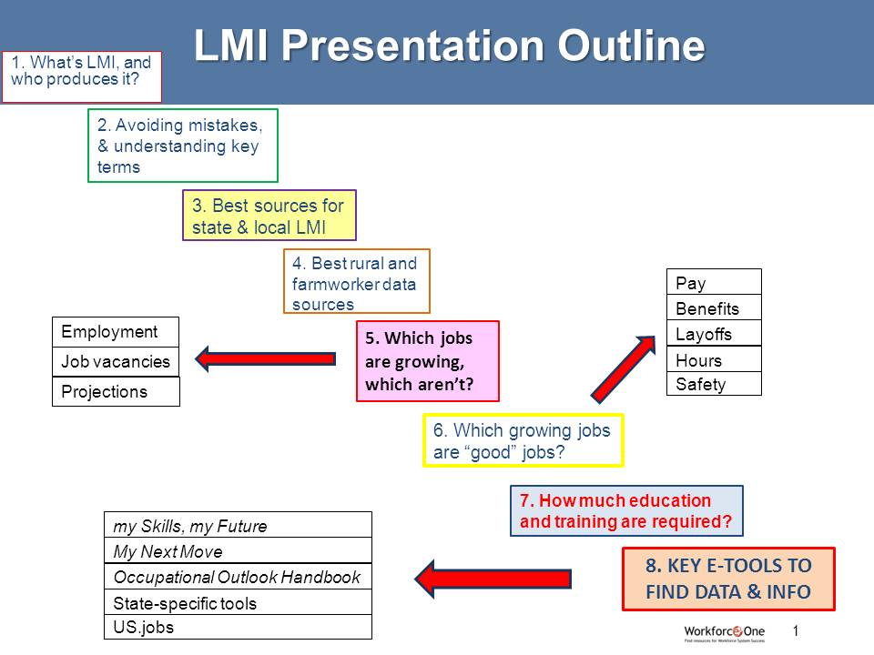
ETA Chart on the Targeting Process for Identifying Occupations for Classroom Training
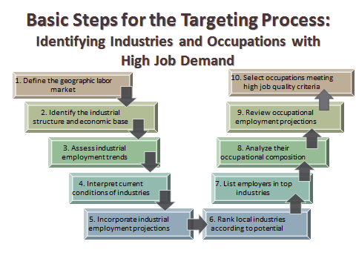

DISCLAIMER: The contents of this resource guide do not necessarily reflect the views or policies of the U.S. Department of Labor, nor does mention of trade names, commercial products, or organizations in any of these sample materials and resources imply any endorsement of the same by DOL or ETA. There are standard labor market analysis calculations made in academia among economists, and those should be applied, in statistically sound ways and with common sense, to the nature of the economic and labor market situation being addressed. Therefore, there can be a great deal of variety in how leadership sets its vision, its goals, its data cut-off criteria, etc., in order to select the most appropriate methods for the types of workforce interventions intended. But, in all of the selections made, methods used, and criteria applied, there should be statistically validity in the approach and a clear intent on the part of stewards of public funding to wisely spend taxpayer resources in areas with the most valuable targeted return on investment back to the community.

Created: August 20, 2015; Revised October 20, 2015; U.S. Department of Labor, Employment and Training Administration

